H.T No
Regulations:
A19

Sreenidhi Institute of Science and Technology
(An Autonomous Institution)
Code No: 7X104 Date: 20-April-2022 (FN)

M.Tech I-Year I-Semester External Examination, April/May - 2022 (Regular/Supplementary)
COMPUTER METHODS IN POWER SYSTEMS (EPE)

Time: 3 Hours Max.Marks:70

Note: a) No additional answer sheets will be provided.
b) All sub-parts of a question must be answered at one place only, otherwise it will not be valued.
c) Missing data can be assumed suitably.

ANSWER ANY FIVE QUESTIONS. EACH QUESTION CARRIES 14 MARKS.

Bloom's Cognitive Levels of Learning (BCLL)
Remember | L1 | Apply | L3 | Evaluate | L5
Understand | L2 | Analyze | L4 | Create | L6

 |  |  | BCLL | CO(s) | Marks
1. |  | Form the Y_{BUS} for the systems shown in below figure 1 using direct inspection method. Take half line charging susceptance as j2 Ω.  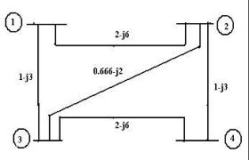  Figure.1 | L3 | CO1 | [14M]
2. |  | Find the Z-Bus for the power system network shown in below figure 2. All reactance’s are in p.u values.  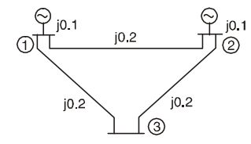  Figure.2 | L2 | CO2 | [14M]
3. |  | Explain the Newton Raphson Load flow method in polar form, and derive the equation to compute the Jacobian matrix elements. | L1 | CO3 | [14M]
4. | a) | Explain the necessity of load flow solution. | L1 | CO4 | [7M]
 | b) | Write an algorithm for Gauss seidal load flow method by considering all types of buses. | L1 | CO4 | [7M]
5. | a) | What is power angle curve? Deduce the relation from a SMIB system having lossless line. | L3 | CO5 | [7M]
 | b) | What is swing equation and derive the swing equation? | L4 | CO5 | [7M]
6. | a) | Explain in detail with the help of neat block diagram about load frequency control of two area system if it is uncontrolled? | L5 | CO6 | [7M]
 | b) | Mention few applications of optimal control theory. | L6 | CO6 | [7M]
7. | a) | Give the steps for modification of existing Z_{BUS}, when a branch Z_{b} is added for existing bus(k) to the reference bus. | L4 | CO1 | [5M]
 | b) | Determine the sequence currents for the system of unbalanced phase currents as given below are drawn by a balanced delta load with Z_{phase}= j10Ω.  Ia= 10<0⁰, Ib =10<180⁰, Ic= 0⁰ | L3 | CO2 | [5M]
 | c) | What is the significance of convergence characteristics? | L2 | CO3 | [4M]
8. | a) | What are the advantages and disadvantages of Runge-Kutta method? | L1 | CO4 | [5M]
 | b) | What is the significance of Power system stability? | L5 | CO5 | [5M]
 | c) | Write briefly about tie line bias control? | L6 | CO6 | [4M]

-- 00 -- 00 –

